**Inspection made by Grupo 4.**

* Don’t have created the controller package.
* The producto ID has not been validated, because when entering the ID we combined letters and numbers and we got an error.

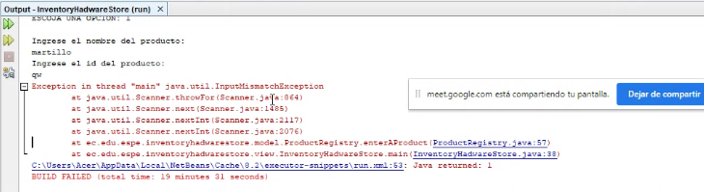

* The amount is not valid to recognize only numbers, when entering letters it gives us an error.
* Prince is not validated to recognize only numbers, when entering letters it gives us an error.
* When viewing Stock, it is printed as Json, with spaces between lines. View capture.

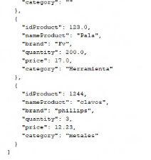

* When choosing the option, it is not validated to recognize numbers, when entering the letter, it gives, us an error.
* The phone number is not validated, when entering letters, an error appears.
* The entry of the identification number or RUC is not validated, it gigves an error when writing letters.
* The screen displays CUSTOMER DEBT, it is not understood what data it is asking for (ambiguity).
* It did not generate an invoicie on screen (We don’t know if it should, but we could asume it).
* Recommendation: optimize the function, so that they are not repeated. See the images of both functions.

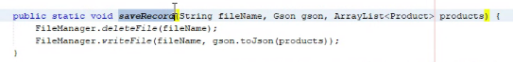



* A ‘hardwarestore’ file is generated, but it is generated empty. View photo.

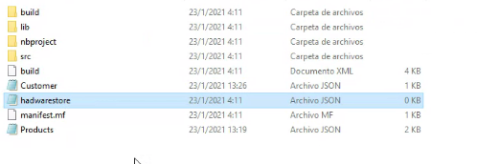

* Check IEEE 830, the table of contents is empty and has certain things incomplete.
* In the diagram of use cases, the client would not be an actor in the system, since in use, there is no agreement.
* The program does not comply with these use cases 'Remove Resgistered Product', 'generate bill'.
* In the class diagram, between 'Customer' and 'CustomerRegistry', there are errors in the association, it puts an address and it does not have the verb. As a recommendation in the above, it would be a dependency. In the aggregation it puts verb and some relationships are wrong. Check.
* Also, there is no note explaining that the FileManager is being used (This was a form recommendation given by Edison).
* In the ProductRegistry the attribute ‘scan: scan’ seems to be wrongly added.
* Also, as a recommendation, between CustomerRegistry and Validation would be a dependency.

